**Project: Build a simple E-commerce website using HTML CSS JS (Use Bootstrap)**

Create a folder with a name **E-commerce website_01**

Inside the E-commerce website_01 folder create **index.html** and **style.css**

Now inside the index.html file create the starter code using “!” + enter

Link the **bootstrap style sheet**

<link rel="stylesheet" href="https://cdn.jsdelivr.net/npm/bootstrap@4.1.3/dist/css/bootstrap.min.css" crossorigin="anonymous">

Link the style sheet using

link rel="stylesheet" href="style.css">

Link the JS script from bootstrap

<script src="https://code.jquery.com/jquery-3.3.1.slim.min.js" crossorigin="anonymous"></script>

  <script src="https://cdn.jsdelivr.net/npm/popper.js@1.14.3/dist/umd/popper.min.js" crossorigin="anonymous"></script>

  <script src="https://cdn.jsdelivr.net/npm/bootstrap@4.1.3/dist/js/bootstrap.min.js" crossorigin="anonymous"></script>

Since we are using many fonts from font awesome we need to link **font awesome “CDN”**

  <link rel="stylesheet" href="https://cdnjs.cloudflare.com/ajax/libs/font-awesome/6.5.2/css/all.min.css" crossorigin="anonymous" referrerpolicy="no-referrer" />

Next is to add “nav bar” to the html from bootsrap. In bootsrap within components we have nav bar types and its respective code. Copy the code and paste it in the index.html.

Now to adjust the padding of the nav bar add **py-3** // the top most value is 5.

<nav class="navbar navbar-expand-lg navbar-light bg-light py-3">

To add logo in the nav bar, remove the anchor tag

    <a class="navbar-brand" href="#">Navbar</a>

Add the below line

<img src="img/logo1.png" alt="nav logo1" style="height:40px;">

To put all the nav links in the right side, inside the unordered list there is class me-auto mb-2 mb-lg-0 remove that add ml-auto

<ul class="navbar-nav me-auto mb-2 mb-lg-0">

Instead of this add the below code

<ul class="navbar-nav ml-auto">

To make the nav bar with “Home” “Shop” “Blog” “About” “Contact Us” we need to delete some of the list items inside the unordered list given by bootstrap. I will show which the things that needs to be deleted are.

<li class="nav-item">

          <a class="nav-link active" aria-current="page" href="#">Home</a>

        </li>

<li class="nav-item dropdown">

          <a class="nav-link dropdown-toggle" href="#" role="button" data-bs-toggle="dropdown" aria-expanded="false">

            Dropdown

          </a>

          <ul class="dropdown-menu">

            <li><a class="dropdown-item" href="#">Action</a></li>

            <li><a class="dropdown-item" href="#">Another action</a></li>

            <li><hr class="dropdown-divider"></li>

            <li><a class="dropdown-item" href="#">Something else here</a></li>

          </ul>

        </li>

        <li class="nav-item">

          <a class="nav-link disabled" aria-disabled="true">Disabled</a>

        </li>

      </ul>

      <form class="d-flex" role="search">

        <input class="form-control me-2" type="search" placeholder="Search" aria-label="Search"/>

        <button class="btn btn-outline-success" type="submit">Search</button>

      </form>

The following list can be added or renamed

  <div class="collapse navbar-collapse" id="navbarSupportedContent">

        <ul class="navbar-nav ml-auto">

          <li class="nav-item"><a class="nav-link" href="#">Home</a></li>

          <li class="nav-item"><a class="nav-link" href="#">Shop</a></li>

          <li class="nav-item"><a class="nav-link" href="#">Blog</a></li>

          <li class="nav-item"><a class="nav-link" href="#">About</a></li>

          <li class="nav-item"><a class="nav-link" href="#">ContactUs</a></li>

          <li class="nav-item d-flex align-items-center">

            <a class="nav-link" href="#"><i class="fa-solid fa-magnifying-glass"></i></a>

            <a class="nav-link" href="#"><i class="fa-solid fa-shopping-bag"></i></a>

          </li>

        </ul>

      </div>

Now I need to add search icon & shopping bag in the nav bar. To do that go to font awesome website and click icon and search for search icon and shopping bag icon. Add them as mentioned above

Now we have to add CSS style to the nav bar elements

To increase the font-size of the nav links, we have a class called

<nav class="navbar navbar-expand-lg navbar-light bg-white py-3 fixed-top">

Bg-light is replaced with bg-white for pure white nav bar color

.navbar {

    font-size: 16px;

}

To increase the space between nav links also transition, color add the following code

.navbar-light .navbar-nav .nav-link {

    padding: 0 20px;

    color: black;

    transition: 0.3s ease;

}

To add some hover effects to nav links and change color when hovering

.navbar-light .navbar-nav .nav-link:hover,

.navbar-light .navbar-nav .nav-link:active{

    color: coral;

}

To adjust the space from both left and right side of the nav bar remove “fluid"

<div class="container-fluid">

<div class="container">

To change the bar in the nav bar, we have make changes to the span tag

<span class="navbar-toggler-icon"></span>

Need to remove the class and add bootstrap class for new bar

<span id="bar"><i class="fa-solid fa-bars"></i></span>

To need add these in style sheet

/*mobile nav*/

.navbar-light .navbar-toggler {

    border: none;

    outline: none;

}

To add styling for the bar in the style sheet

#bar{

    font-size: 1.5rem;

    padding: 7px;

    cursor: pointer;

    font-weight: 500;

    transition: 0.3s ease;

    color: black;

}

To add hover effect on the bar in the style sheet

#bar:hover,

#bar:active {

    color: #fff;

}

To change the background color of the bar while cursor hovers over it

Go to the website, then right click and go to inspect,

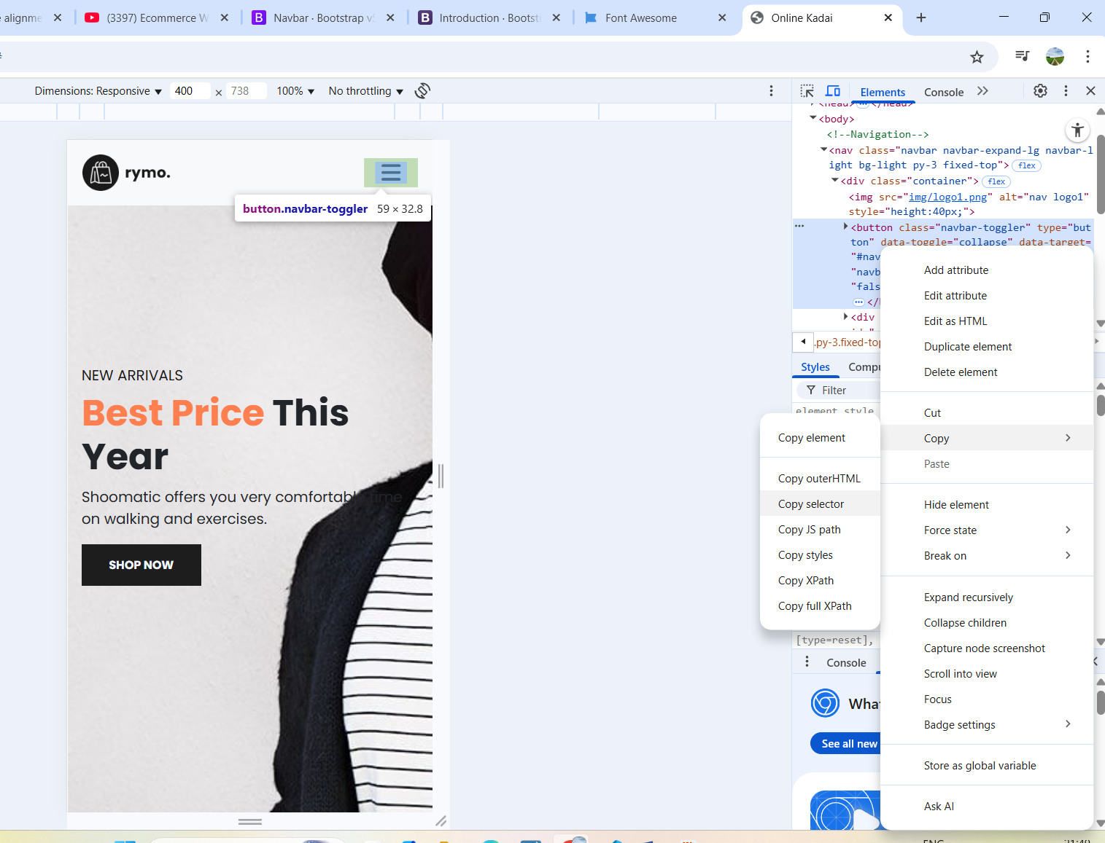

Add this in style sheet also when hover and focus color change to orange

@media only screen and (max-width:991px){

    body > nav > div > button:hover,

    body > nav > div > button:focus {

        background-color: #fb774b;

    }

}

To adjust the nav bar links again go to inspect page and copy the link using copy selector and paste it in the style sheet below media query.

 #navbarSupportedContent > ul > li:nth-child(1) > a

And remove > li:nth-child(1) > a

#navbarSupportedContent > ul{

        margin: 1rem;

        justify-content: flex-end;

        align-items: flex-end;

        text-align: right;

    }

Now the nav bar moves right side but it still has extra padding, to adjust that again go to inspect and copy the

#navbarSupportedContent > ul > li:nth-child(1) > a

Inside the li:nth-child(1) is given for first “home” link remove that and instead put n.

#navbarSupportedContent > ul > li:nth-child(n) > a {

        padding: 10px 0;

    }

Up to this **nav bar** is done

Now we go the **Home-banner section**, we add the following element under section home.

  <section id="home">

    <div class="">

        <h5>NEW ARRIVALS</h5>

        <h1><span>Best Price</span> This Year</h1>

        <p>Shoomatic offers you very comfortable time<br>

            on walking and exercises.</p>

            <button>Shop Now</button>

    </div>

  </section>

To style we need to use style sheet

First we need to style the h1 element where we give separate color for the “Best Price”

#home span{

    color: coral;

}

Second we need to style the shop now button, we will be using the button as global tag.

button {

    font-size: 0.8rem;

    font-weight: 700;

    outline: none;

    border: none;

    background-color: #1d1d1d;

    color: aliceblue;

    padding: 13px 30px;

    cursor: pointer; //clickable button

    text-transform: uppercase;

    transition: 0.3s ease;

}

To make hover effect on the button

button:hover {

    background-color: #3a3833;

}

To add background image in the home section

#home {

    background-image: url("img/back.jpg");

    width: 100%;

    height: 100vh;

    background-size: cover;

    background-position: top center;

}

To bring the text in the home section to middle

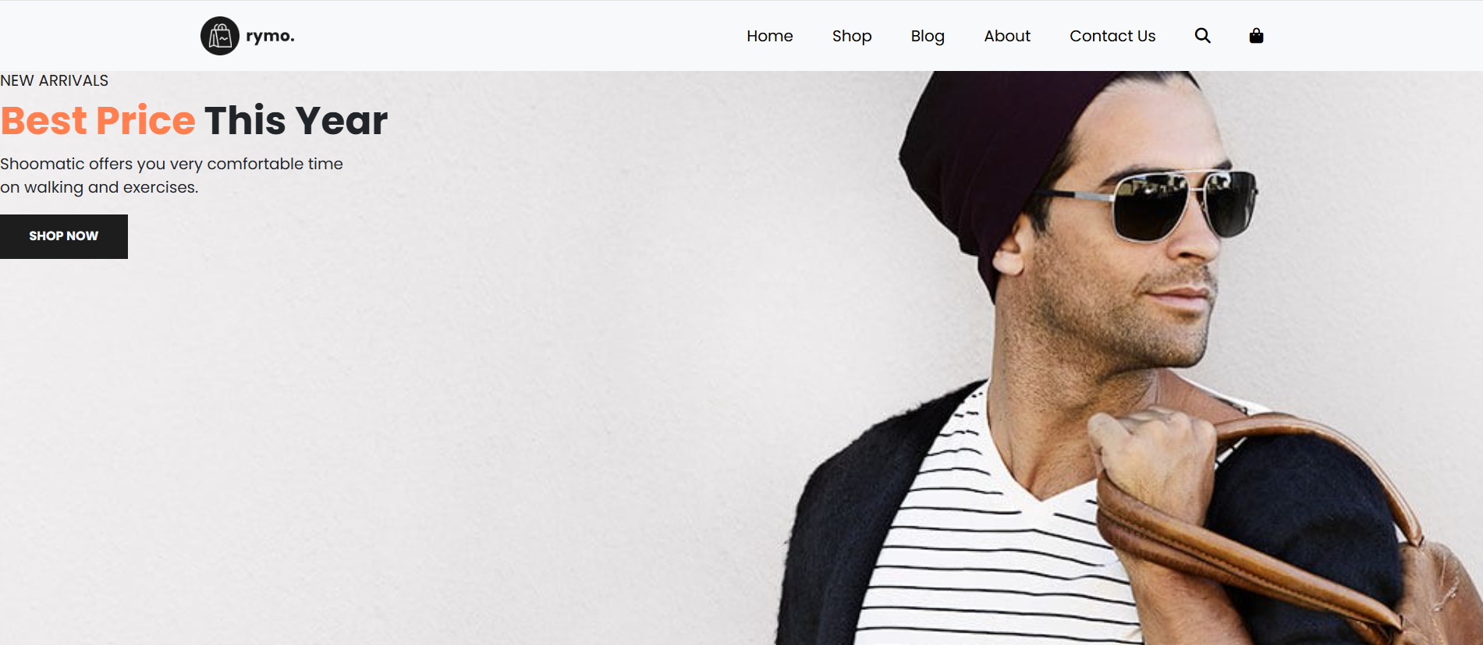

#home {

    background-image: url("img/back.jpg");

    width: 100%;

    height: 100vh;

    background-size: cover;

    background-position: top center;

    display: flex;

These are the changes to bring the text into center

    flex-direction: column;

    justify-content: center;

    align-items:flex-start;

}

To bring the space like the nav bar, add class “container” to the div element in the section

<div class="container">

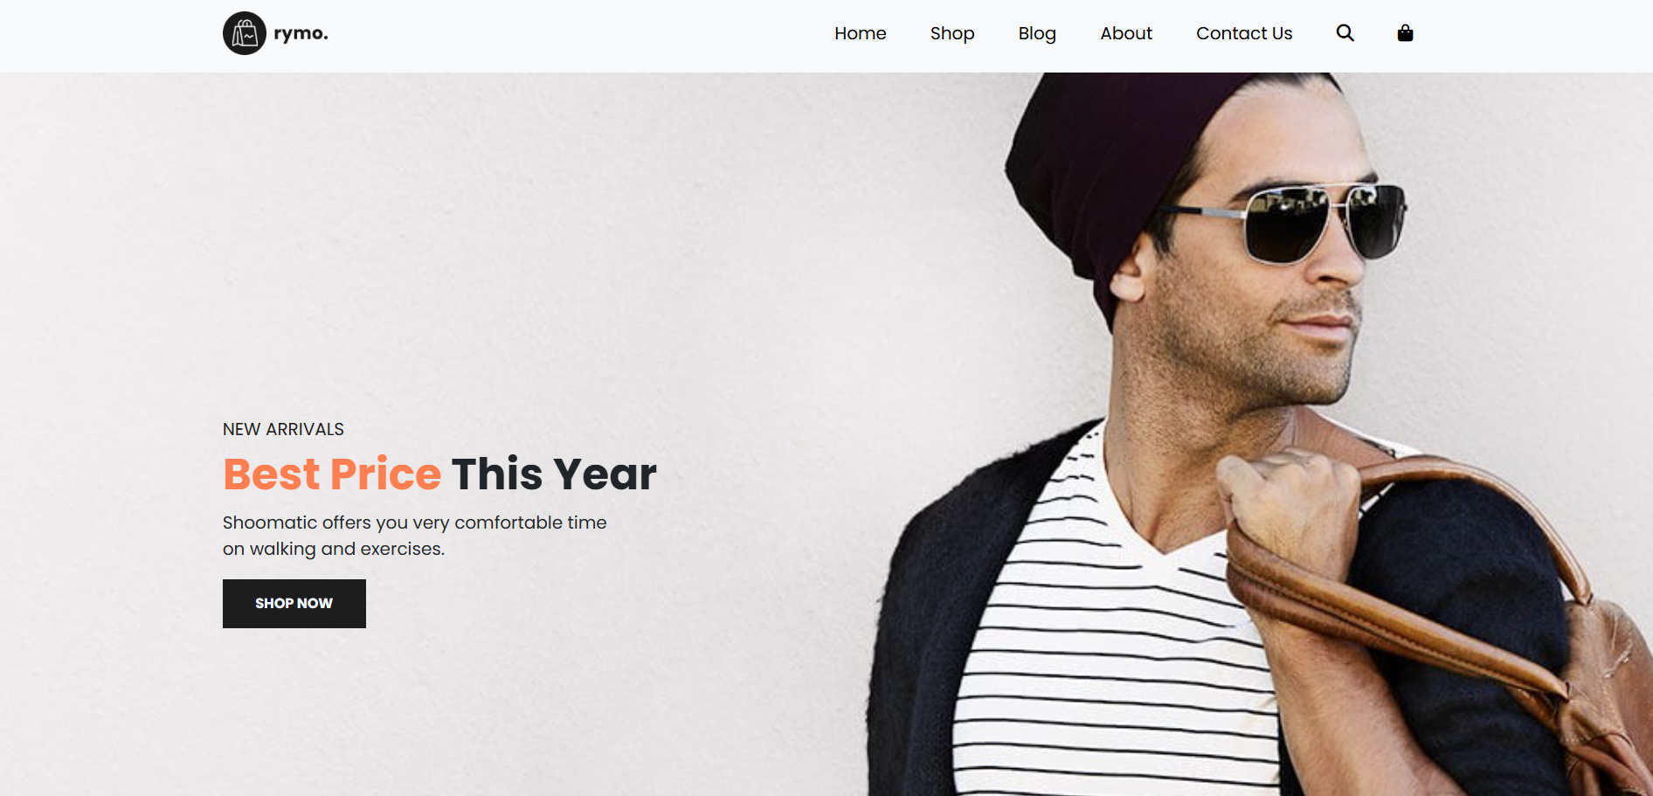

This space is equal in nav bar as well as section

To fix the nav bar even when scrolling down, we need to add fixed-top (a bootstrap classs)

<nav class="navbar navbar-expand-lg navbar-light bg-light py-3 fixed-top">

Changes to be made in style sheet for fixed nav bar, additionally we add box-shadow to give a shadow look.

.navbar {

These are the changes for fixed top

    font-size: 16px;

    top: 0;

    left: 0;

box-shadow: 0 5px 10px rgba(0, 0, 0, 0.1);

}

To bring the background image slightly below, inside the #home add 60px initial it was top and center only.

 background-position: top 60px center;

Up to this **Home-banner section** is completed

***************************************************************************

Next we go to **Brand section** in the html file, add the following code

  <section id="Brand">

    <div class="row"> // I want one row where I add all the brand logos

      <img src="/img/brand/1.png" alt="">

    </div>

  </section>

I want to remove the slider in the bottom. To do that add new class in the section called container which will remove the slider in the bottom and also align the space in the side.

<section id="Brand" class="container">

We have to add img-fluid class which make the image responsive to different screens

<img class="img-fluid col-lg-2 col-md-4 col-sm-6" src="/img/brand/1.png" alt="">

Here the bootstrap splits the website into 12 columns for different device, we specify in html to display “col-lg-2” – large screen 2 columns, “col-md-4” – medium screen 4 columns and “col-sm-6” – small screen 6 columns.

To add space to the brand section we add margin=0 and padding=5.

<div class="row m-0 py-5">

Up to this **Brand section** is completed

Now we go to **New section** by using section element

  <section id="New" class="w-100">

    <div class="row p-0 m-0">

      <div class="one col-lg-4 col-md-12 col-12 p-0">

        <img class="img-fluid" src="/img/new/1.jpg" alt="">

          <div class="details">

            <h2>Extreme Rare Sneakers</h2>

            <button class="text-uppercase">Shop Now</button>

          </div>

      </div>

    </div>

  </section>

Section id is given as “New” and bootstrap class used to set the width to 100% to remove the bottom slider. Inside the section element new div with class name “row with padding -0 and margin -0” created where we will place the 3 images and its details. Again inside the div we create another div class “one col-lg-4 col-md-12 col-12 p-o” (larger screen 4 columns, medium screens 12 columns and small screen 12 and padding -0), for individual images. Inside that we add image and use “img-fluid” class for responsive website design. Below that we add div with class name “details” for adding the image details. “h2” and “button” element is used. Repeat this two times for another two images also.

  <section id="New" class="w-100">

    <div class="row p-0 m-0">

      <div class="one col-lg-4 col-md-12 col-12 p-0">

        <img class="img-fluid" src="/img/new/1.jpg" alt="">

          <div class="details">

            <h2>Extreme Rare Sneakers</h2>

            <button class="text-uppercase">Shop Now</button>

          </div>

      </div>

      <div class="one col-lg-4 col-md-12 col-12 p-0">

        <img class="img-fluid" src="/img/new/2.jpg" alt="">

          <div class="details">

            <h2>Awesome Blank Outfit</h2>

            <button class="text-uppercase">Shop Now</button>

          </div>

      </div>

      <div class="one col-lg-4 col-md-12 col-12 p-0">

        <img class="img-fluid" src="/img/new/3.jpg" alt="">

          <div class="details">

            <h2>Sportwear Up to 50% Off</h2>

            <button class="text-uppercase">Shop Now</button>

          </div>

      </div>

    </div>

  </section>

This is the complete section with 3 images, we observe the images are not in same size,

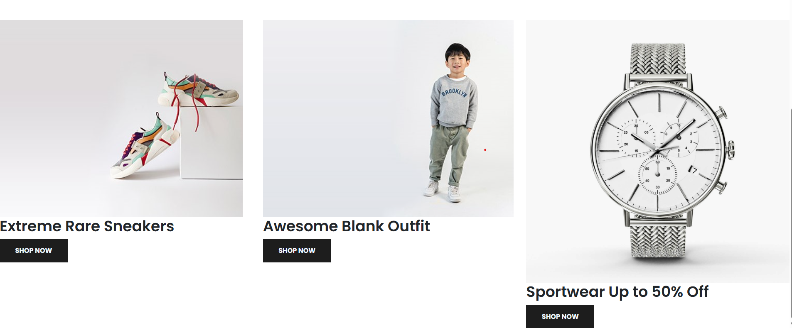

To adjust that we need to make adjustments, here are they. Use the Id=“new” and go to style sheet.

#New .one img {

    width: 100%;

    height: 100%;

    background-position: center center;

    background-repeat: no-repeat;

    background-size: cover;

    position: relative;

}

Now the images are taking same width and height.

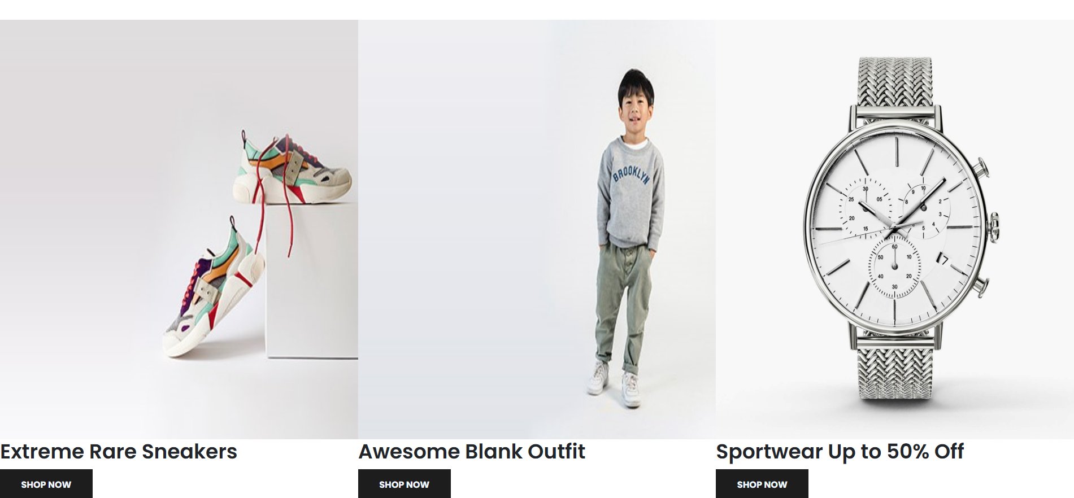

To bring the details into the image,

#New .one .details {

    position: absolute;

    width: 100%;

    height: 100%;

    top: 0;

    left: 0;

    transition: 0.3s ease;

}

To change the color of the image background during hover effect,

#New .one:hover .details {

    cursor: pointer;

    background-color:rgba(245, 178, 178, 0.7);

}

Now we have align the text details,

#New .one .details button {

    display: inline-block;

    font-size: 14px;

    font-weight: 500;

    color: #2a2a2a;

    background: none;

    text-transform: uppercase;

    border-bottom: 1px solid #2a2a2a;

    padding: 2.5px;

    transform: translateY(70px);

    transition: 0.3s ease;

}

Now when we hover over the button it should change the color,

#New .one .details button:hover {

    color: #fff;

    border-bottom: 1px solid #fff;

}

We need to align the details “h2” in the left center, here we target the individual items so put child(1)

#New .one:nth-child(1) .details {

    display: flex;

    justify-content: center;

    flex-direction: column;

    align-items: flex-start;

    text-align: start;

}

Similarly for 2nd and 3rd item

#New .one:nth-child(2) .details {

    display: flex;

    justify-content: center;

    flex-direction: column;

    align-items: center;

    text-align: center;

}

#New .one:nth-child(3) .details {

    display: flex;

    justify-content: center;

    flex-direction: column;

    align-items: flex-end;

    text-align: end;

}

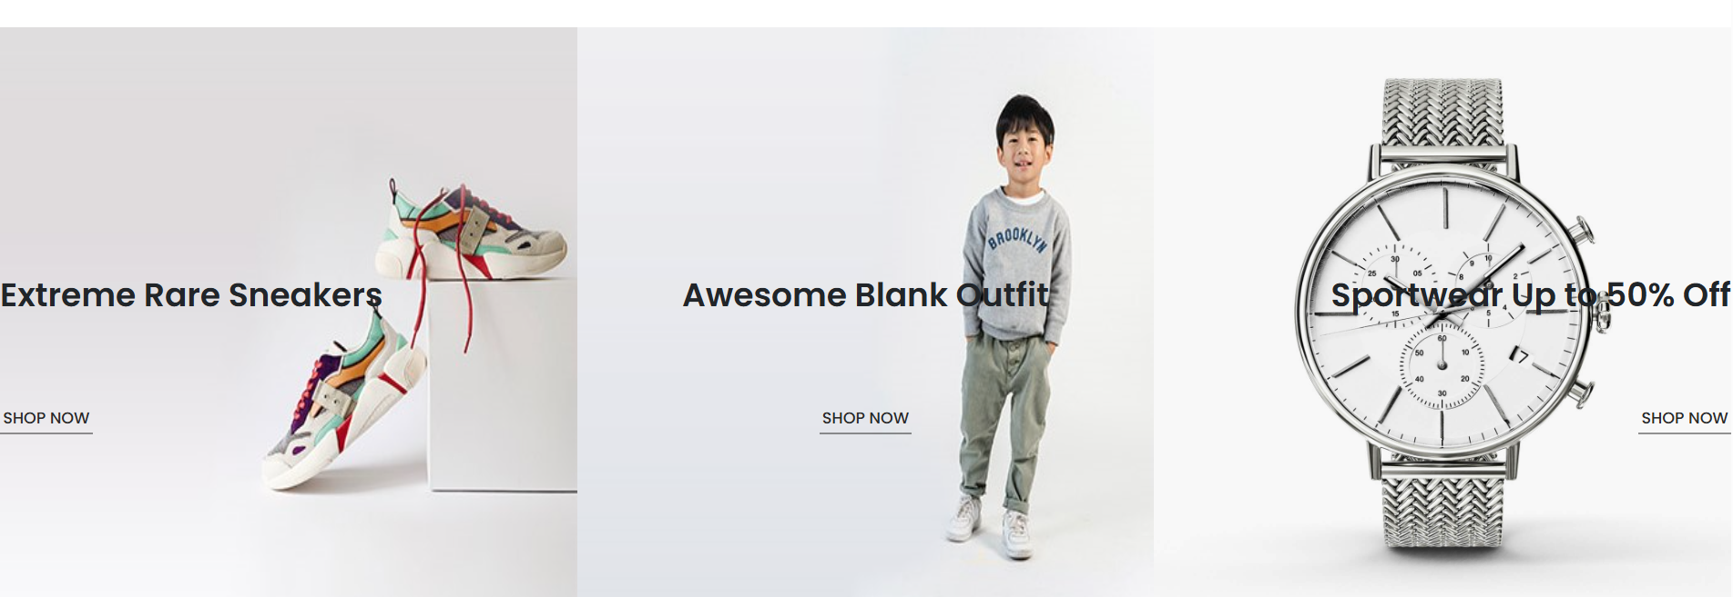

Up to this **New section** is completed

**Featured section** starts here,

Following cold adds the heading “h3” “line below the heading” and “paragraph”. For extra spacing we add margin and padding for both section and div classes.

  <section id="Featured" class="my-5 pb-5">

    <div class="container text-center mt-5 py-5">

      <h3>Our Featured</h3>

      <hr>

      <p>Here you can check out our new products with fair price on rymo.</p>

    </div>

  </section>

Now we add product class where four products are in one row.

  <section id="Featured" class="my-5 pb-5">

    <div class="container text-center mt-5 py-5">

      <h3>Our Featured</h3>

      <hr>

      <p>Here you can check out our new products with fair price on rymo.</p>

    </div>

    <div class="row mx-auto container-fluid">

      <div class="product text-center col-lg-3 col-md-4 col-12">

        <img class="img-fluid mb-3" src="/img/featured/1.jpg" alt="">

          <div class="star">

              <i class="fa-solid fa-star"></i>

              <i class="fa-solid fa-star"></i>

              <i class="fa-solid fa-star"></i>

              <i class="fa-solid fa-star"></i>

              <i class="fa-solid fa-star"></i>

          </div>

          <h5 class="p-name">Sports Shoes</h5>

          <h4 class="p-price">Rs. 292.00</h4>

          <button class="buy-btn">Buy Now</button>

      </div>

      <div class="product text-center col-lg-3 col-md-4 col-12">

        <img class="img-fluid mb-3" src="/img/featured/2.jpg" alt="">

          <div class="star">

              <i class="fa-solid fa-star"></i>

              <i class="fa-solid fa-star"></i>

              <i class="fa-solid fa-star"></i>

              <i class="fa-solid fa-star"></i>

              <i class="fa-solid fa-star"></i>

          </div>

          <h5 class="p-name">Walking Shoes</h5>

          <h4 class="p-price">Rs. 162.00</h4>

          <button class="buy-btn">Buy Now</button>

      </div>

      <div class="product text-center col-lg-3 col-md-4 col-12">

        <img class="img-fluid mb-3" src="/img/featured/3.jpg" alt="">

          <div class="star">

              <i class="fa-solid fa-star"></i>

              <i class="fa-solid fa-star"></i>

              <i class="fa-solid fa-star"></i>

              <i class="fa-solid fa-star"></i>

              <i class="fa-solid fa-star"></i>

          </div>

          <h5 class="p-name">backpack</h5>

          <h4 class="p-price">Rs. 499.00</h4>

          <button class="buy-btn">Buy Now</button>

      </div>

      <div class="product text-center col-lg-3 col-md-4 col-12">

        <img class="img-fluid mb-3" src="/img/featured/4.jpg" alt="">

          <div class="star">

              <i class="fa-solid fa-star"></i>

              <i class="fa-solid fa-star"></i>

              <i class="fa-solid fa-star"></i>

              <i class="fa-solid fa-star"></i>

              <i class="fa-solid fa-star"></i>

          </div>

          <h5 class="p-name">Skull Cap</h5>

          <h4 class="p-price">Rs. 92.00</h4>

          <button class="buy-btn">Buy Now</button>

      </div>

    </div>

  </section>

Now we need to add spacing in the details, for that we need to use style sheet using the product class.

.product {

    cursor: pointer;

    margin-bottom: 2rem;

}

Now we need to create hover effect.

.product:hover img {

    opacity: 0.7;

}

We have change the styling for the buttons inside the featured section, and also the button should not visible first, it should be visible only when we hover over the product.

.product .buy-btn {

    background-color: #fb774b;

    transform: translateY(20px);

    opacity: 0;

    transition: 0.3s all;

}

.product:hover .buy-btn {

    transform: translateY(0);

    opacity: 1;

}

Next is to style the horizontal line, this line comes in many places in the website, so it is done in the global section.

hr {

    width: 30px;

    height: 2px;

    background-color: #fb774b;

}

We need to add class in the html doc,

<hr class="mx-auto">

Where mx-auto means margin left and right is auto.

The star (rating) below the product needs styling –color and font-size. For that we need to adjust the style sheet using its class called “star i” i because we concentrate on the i tag specifically.

.star i {

    font-size: 0.8rem;

    color: goldenrod;

}

To give the star spacing

.star {

    padding: 10px 0;

}

Up to this **featured section** completed.

Now let’s begin the **Paradox banner section**

  <section id="Banner">

    <div class="">

      <h4>MID SEASON'S SALE</h4>

      <h1>AUTUMN COLLECTION<br>UPTO 20% OFF</h1>

      <button class="text-uppercase">Shop Now</button>

    </div>

  </section>

We have put a background image as parallax background. Go to the style sheet.

#Banner {

    background-image: url("img/banner/2.jpg");

    width: 100%;

    height: 80vh;

    background-size: cover;

    background-position: top 70px center;

    background-repeat: no-repeat;

    background-attachment: fixed; // this makes the BG looks like parallax BG

    display: flex;

    flex-direction: column;

    justify-content: center;

    align-items:flex-start;

Again to give spacing for the text contents, we use bootstrap class container.

<div class="container">

Now we provide styling to the heading tag h4, h1 and button.

#Banner h4 {

    color: #d8d8d8;

}

#Banner h1 {

    color: #fff;

}

#Banner button {

    background-color: #fb774b;

}

For adding the space in the top and bottom for the background image. Using the bootstrap classes, add my-5 (margin top and bottom) & py-5 (padding top and bottom).

<section id="Banner" class="my-5 py-5">

Up to this **Parallax banner is completed**.

**Dresses and Tees section** starts here,

Since already we written code for the featured section, we will use the same code for this section as well.

  <section id="Clothes" class="my-5">

    <div class="container text-center mt-5 py-5">

      <h3>Ladies Special</h3>

      <hr class="mx-auto">

      <p>Here you can check out our new products with fair price on rymo.</p>

    </div>

    <div class="row mx-auto container-fluid">

      <div class="product text-center col-lg-3 col-md-4 col-12">

        <img class="img-fluid mb-3" src="/img/clothes/1.jpg" alt="">

          <div class="star">

              <i class="fa-solid fa-star"></i>

              <i class="fa-solid fa-star"></i>

              <i class="fa-solid fa-star"></i>

              <i class="fa-solid fa-star"></i>

              <i class="fa-solid fa-star"></i>

          </div>

          <h5 class="p-name">Striped Blazer Suit Set</h5>

          <h4 class="p-price">Rs. 1899.00</h4>

          <button class="buy-btn">Buy Now</button>

      </div>

      <div class="product text-center col-lg-3 col-md-4 col-12">

        <img class="img-fluid mb-3" src="/img/clothes/2.jpg" alt="">

          <div class="star">

              <i class="fa-solid fa-star"></i>

              <i class="fa-solid fa-star"></i>

              <i class="fa-solid fa-star"></i>

              <i class="fa-solid fa-star"></i>

              <i class="fa-solid fa-star"></i>

          </div>

          <h5 class="p-name">Striped Bodycon Dress</h5>

          <h4 class="p-price">Rs. 1622.00</h4>

          <button class="buy-btn">Buy Now</button>

      </div>

      <div class="product text-center col-lg-3 col-md-4 col-12">

        <img class="img-fluid mb-3" src="/img/clothes/3.jpg" alt="">

          <div class="star">

              <i class="fa-solid fa-star"></i>

              <i class="fa-solid fa-star"></i>

              <i class="fa-solid fa-star"></i>

              <i class="fa-solid fa-star"></i>

              <i class="fa-solid fa-star"></i>

          </div>

          <h5 class="p-name">Black Tees</h5>

          <h4 class="p-price">Rs. 499.00</h4>

          <button class="buy-btn">Buy Now</button>

      </div>

      <div class="product text-center col-lg-3 col-md-4 col-12">

        <img class="img-fluid mb-3" src="/img/clothes/4.jpg" alt="">

          <div class="star">

              <i class="fa-solid fa-star"></i>

              <i class="fa-solid fa-star"></i>

              <i class="fa-solid fa-star"></i>

              <i class="fa-solid fa-star"></i>

              <i class="fa-solid fa-star"></i>

          </div>

          <h5 class="p-name">White Tees</h5>

          <h4 class="p-price">Rs. 492.00</h4>

          <button class="buy-btn">Buy Now</button>

      </div>

    </div>

  </section>

**Similarly repeat it for Watches and Shoes section**.

Footer section complete HTML Code

  <footer class="mt-5 py-5">

   <div class="row container mx-auto pt-5">

      <div class="footer-one col-lg-3 col-md-6 col-12">

        <img src="/img/logo2.png" alt="">

        <p>Rymo offers stylish, affordable fashion with quality and comfort,

           blending youthful energy and trendy designs in clothing, footwear, and accessories.</p>

      </div>

      <div class="footer-one col-lg-3 col-md-6 col-12">

        <h5 class="pb-2">Featured</h5>

        <ul class="text-uppercase list-unstyled">

          <li><a href="#">Men</a></li>

          <li><a href="#">Women</a></li>

          <li><a href="#">New Arrivals</a></li>

          <li><a href="#">Shoes</a></li>

          <li><a href="#">Clothes</a></li>

        </ul>

      </div>

      <div class="footer-one col-lg-3 col-md-6 col-12">

        <h5 class="pb-2">Contact Us</h5>

          <div>

            <h6 class="text-uppercase">Address</h6>

            <p>1/200, R.S.Puram,CBE,India</p>

          </div>

          <div>

            <h6 class="text-uppercase">Phone</h6>

            <p>0422 2348956</p>

          </div>

          <div>

            <h6 class="text-uppercase">Email</h6>

            <p>mail@rymo.com</p>

          </div>

      </div>

      <div class="footer-one col-lg-3 col-md-6 col-12">

        <h5 class="pb-2">Instagram</h5>

          <div class="row">

            <img class="img-fluid w-25 h-100 m-2" src="/img/insta/1.jpg" alt="">

            <img class="img-fluid w-25 h-100 m-2" src="/img/insta/2.jpg" alt="">

            <img class="img-fluid w-25 h-100 m-2" src="/img/insta/3.jpg" alt="">

            <img class="img-fluid w-25 h-100 m-2" src="/img/insta/4.jpg" alt="">

            <img class="img-fluid w-25 h-100 m-2" src="/img/insta/5.jpg" alt="">

          </div>

      </div>

    </div>

    <div class="copyright mt-5">

      <div class="row container mx-auto">

        <div class="col-lg-3 col-md-6 col-12">

          <img src="img/payment.png" alt="">

        </div>

        <div class="col-lg-4 col-md-6 col-12 text-nowrap">

          <p>rymo eCommerce © 2025. All rights reserved</p>

        </div>

        <div class="col-lg-4 col-md-6 col-12">

          <a href="#"><i class="fa-brands fa-facebook-f"></i></a>

          <a href="#"><i class="fa-brands fa-twitter"></i></a>

          <a href="#"><i class="fa-brands fa-linkedin"></i></a>

        </div>

      </div>

    </div>

  </footer>

Footer consists of one row which has (4) multiple columns

Column 1

<div class="footer-one col-lg-3 col-md-6 col-12">

        <img src="/img/logo2.png" alt="">

        <p>Rymo offers stylish, affordable fashion with quality and comfort,

           blending youthful energy and trendy designs in clothing, footwear, and accessories.</p>

      </div>

Here in this column we add image (logo) and paragraph. It has a bootstrap class names footer-one. To make it responsive to different screen size we add bootstrap class - Large screen 3 col, medium 6 col, and small 12 col is added

Column 2

<div class="footer-one col-lg-3 col-md-6 col-12">

        <h5 class="pb-2">Featured</h5>

        <ul class="text-uppercase list-unstyled">

          <li><a href="#">Men</a></li>

          <li><a href="#">Women</a></li>

          <li><a href="#">New Arrivals</a></li>

          <li><a href="#">Shoes</a></li>

          <li><a href="#">Clothes</a></li>

        </ul>

      </div>

This column takes similar class names footer-one. Large screen 3 col, medium 6 col, and small 12 col. additionally it has h5 tag and un-ordered list. To make the text inside the anchor tag to uppercase we use bootstrap class called text-uppercase in the ul tag. To remove bullet points we use list-unstyled. To provide spacing for the h5 tag we provide class pb-2 (padding bottom).

To remove slider in the bottom and provide spacing we use

<div class="row container mx-auto pt-5">

Column 3

<div class="footer-one col-lg-3 col-md-6 col-12 mb-3">

        <h5 class="pb-2">Contact Us</h5>

          <div>

            <h6 class="text-uppercase">Address</h6>

            <p>R.S.Puram,CBE,India</p>

          </div>

          <div>

            <h6 class="text-uppercase">Phone</h6>

            <p>0422 2348956</p>

          </div>

          <div>

            <h6 class="text-uppercase">Email</h6>

            <p>reach_us@rymo.com</p>

          </div>

      </div>

Here we use h5, h6 and p tag. For making the text uppercase, bootstrap class text-uppercase is used. For h5 tag we provide bootstrap class padding bottom spacing pb-2.

Column 4

<div class="footer-one col-lg-3 col-md-6 col-12">

        <h5 class="pb-2">Instagram</h5>

          <div class="row">

            <img class="img-fluid w-25 h-100 m-2" src="/img/insta/1.jpg" alt="">

            <img class="img-fluid w-25 h-100 m-2" src="/img/insta/2.jpg" alt="">

            <img class="img-fluid w-25 h-100 m-2" src="/img/insta/3.jpg" alt="">

            <img class="img-fluid w-25 h-100 m-2" src="/img/insta/4.jpg" alt="">

            <img class="img-fluid w-25 h-100 m-2" src="/img/insta/5.jpg" alt="">

          </div>

      </div>

Similar to contact us section we provide bootstrap class pb-2 for the spacing and img-fluid w-25 h-100 m-2 for the responsive design.

Bottom copyright section

<div class="copyright mt-5">

      <div class="row container mx-auto">

        <div class="col-lg-3 col-md-6 col-12 mb-4">

          <img src="img/payment.png" alt="">

        </div>

        <div class="col-lg-4 col-md-6 col-12 text-nowrap mb-2">

          <p>rymo eCommerce © 2025. All rights reserved</p>

        </div>

        <div class="col-lg-4 col-md-6 col-12">

          <a href="#"><i class="fa-brands fa-facebook-f"></i></a>

          <a href="#"><i class="fa-brands fa-twitter"></i></a>

          <a href="#"><i class="fa-brands fa-linkedin"></i></a>

        </div>

      </div>

    </div>

Here we have single row- used bootstrap class container with mx-auto.

Inside that we create three div elements for – payment option logo, copyrights, and social media logos. For each div we use bootstrap class col-lg-3 col-md-6 col-12 for responsive design. Also for icons we use font awesome icons “i” tag within the “a” tag. To make the copyright line without break we use bootstrap class called text-nowrap.

To make the style for the footer, we use style sheet.

footer {

    background-color: #222222;

}

This makes the background color to dark.

footer h5 {

    color: #d8d8d8;

    font-weight: 700;

    font-size: 1.2rem;

}

For all h5 tag we use color, font-size and font-weight.

footer li {

    padding-bottom: 4px;

}

The list elements need spacing, we provide padding-bottom.

footer li a {

    font-size: 0.8rem;

    color: #999;

}

The text inside the list is given font-size and color.

footer li a:hover {

    color: #d8d8d8;

}

We create a hover effect on the list text content and change its color.

footer p {

    color: #999;

    font-size: 0.8rem;

}

Similarly we provide color and font-size to paragraphs.

footer .copyright a {

    color: #000;

    width: 38px;

    height: 38px;

    background-color: #fff;

    display: inline-block;

    text-align: center;

    line-height: 38px;

    border-radius: 50%;

    transition: 0.3s ease;

    margin: 0 5px;

}

Here for the copyright class we add above mentioned styling – this takes the styling and apply it to the social media icons. It provide the border radius and other transition as well.

footer .copyright a:hover {

    color: #fff;

    background-color:#fb774b;

}

When hover over it, the color and background color changes.

End of Home section - page 1

Now we will start the **shop page coding**.

Begin by creating a new html file called Shop.html in the same project folder where you created index.html. we need to add **bootstrap cdn link, font awesome icon link, external style sheet and js script**. Instead of doing it again **copy the same from the index.html and paste it here.**

<!DOCTYPE html>

<html lang="en">

<head>

  <meta charset="UTF-8">

  <meta name="viewport" content="width=device-width, initial-scale=1.0">

  <title>Rymo.com Shop Page</title>

  <!-- Bootstrap 4 CSS -->

  <link rel="stylesheet" href="https://cdn.jsdelivr.net/npm/bootstrap@4.1.3/dist/css/bootstrap.min.css" crossorigin="anonymous">

  <!-- Font Awesome -->

  <link rel="stylesheet" href="https://cdnjs.cloudflare.com/ajax/libs/font-awesome/6.5.2/css/all.min.css" crossorigin="anonymous" referrerpolicy="no-referrer" />

  <link rel="stylesheet" href="style.css">

</head>

<body>

JS script

  <!-- Bootstrap 4 JS + Popper -->

  <script src="https://code.jquery.com/jquery-3.3.1.slim.min.js" crossorigin="anonymous"></script>

  <script src="https://cdn.jsdelivr.net/npm/popper.js@1.14.3/dist/umd/popper.min.js" crossorigin="anonymous"></script>

  <script src="https://cdn.jsdelivr.net/npm/bootstrap@4.1.3/dist/js/bootstrap.min.js" crossorigin="anonymous"></script>

</body>

</html>

We have to include the nav bar and footer section. Copy and paste the nav bar and footer section from index.html to shop.html.

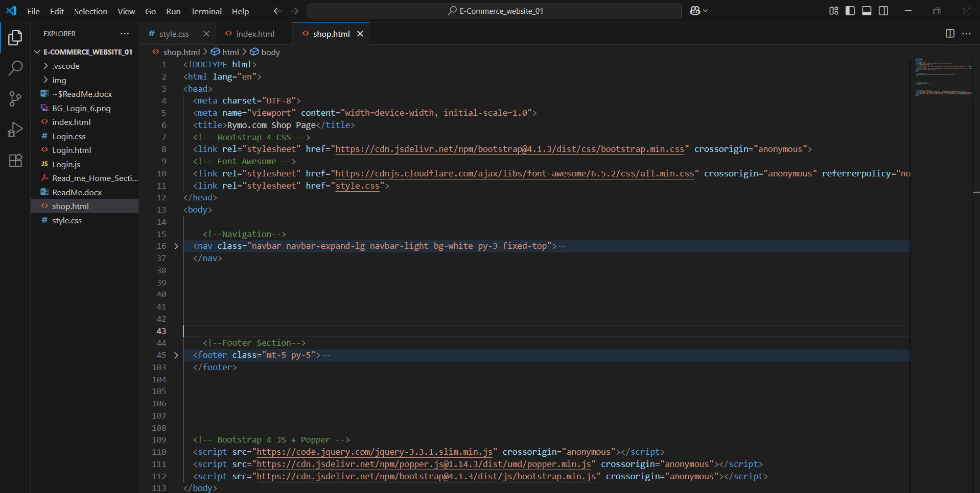

After doing this check the live preview of the shop.html. Now let’s create a product listings in the shop page by just copying the code featured section from index.html.

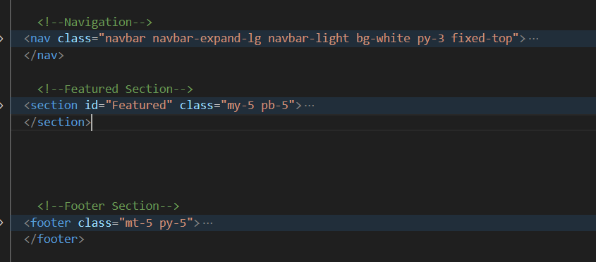

To adjust the spacing, change the padding top and bottom to 5 by changing the bootstrap class

<section id="Featured" class="my-5 py-5">

**my means margin top and bottom & py means padding top and bottom** -5. This gives extra spacing.

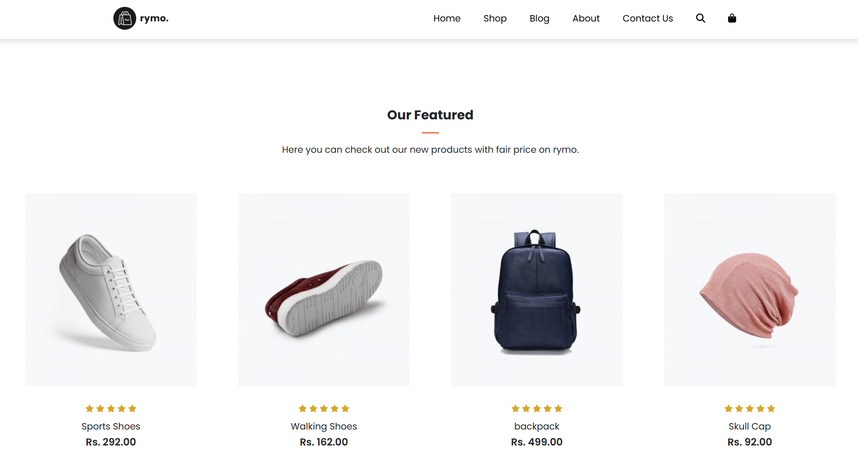

We want the boxed section to be on the **left instead of centre**. To make that,

<section id="Featured" class="my-5 py-5">

    <div class="container text-center mt-5 py-5">

      <h3>Our Featured</h3>

      <hr class="mx-auto">

      <p>Here you can check out our new products with fair price on rymo.</p>

    </div>

We have **to remove the bootstrap class = “text-center”**, this class will bring the text to center position. Also remove hr **class= “mx-auto”**

<section id="Featured" class="my-5 py-5">

    <div class="container mt-5 py-5">

      <h3>Our Featured</h3>

      <hr>

      <p>Here you can check out our new products with fair price on rymo.</p>

    </div>

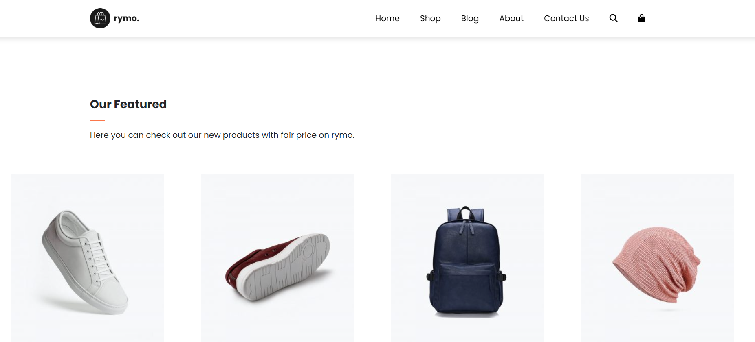

Now let’s work on the product section. Basically “container-fluid” class is used to add some space in the left and right. But we need more space from left and right so we need to just keep “container” instead of “container-fluid”

From this

<div class="row mx-auto container-fluid">

To this

div class="row mx-auto container">

Next we need to populate the product section with more products in multiple rows. To do that we need to copy and paste the div section.

<div class="product text-center col-lg-3 col-md-4 col-12">

        <img class="img-fluid mb-3" src="/img/featured/1.jpg" alt="">

          <div class="star">

              <i class="fa-solid fa-star"></i>

              <i class="fa-solid fa-star"></i>

              <i class="fa-solid fa-star"></i>

              <i class="fa-solid fa-star"></i>

              <i class="fa-solid fa-star"></i>

          </div>

          <h5 class="p-name">Sports Shoes</h5>

          <h4 class="p-price">Rs. 292.00</h4>

          <button class="buy-btn">Buy Now</button>

      </div>

      <div class="product text-center col-lg-3 col-md-4 col-12">

        <img class="img-fluid mb-3" src="/img/featured/2.jpg" alt="">

          <div class="star">

              <i class="fa-solid fa-star"></i>

              <i class="fa-solid fa-star"></i>

              <i class="fa-solid fa-star"></i>

              <i class="fa-solid fa-star"></i>

              <i class="fa-solid fa-star"></i>

          </div>

          <h5 class="p-name">Walking Shoes</h5>

          <h4 class="p-price">Rs. 162.00</h4>

          <button class="buy-btn">Buy Now</button>

      </div>

      <div class="product text-center col-lg-3 col-md-4 col-12">

        <img class="img-fluid mb-3" src="/img/featured/3.jpg" alt="">

          <div class="star">

              <i class="fa-solid fa-star"></i>

              <i class="fa-solid fa-star"></i>

              <i class="fa-solid fa-star"></i>

              <i class="fa-solid fa-star"></i>

              <i class="fa-solid fa-star"></i>

          </div>

          <h5 class="p-name">backpack</h5>

          <h4 class="p-price">Rs. 499.00</h4>

          <button class="buy-btn">Buy Now</button>

      </div>

      <div class="product text-center col-lg-3 col-md-4 col-12">

        <img class="img-fluid mb-3" src="/img/featured/4.jpg" alt="">

          <div class="star">

              <i class="fa-solid fa-star"></i>

              <i class="fa-solid fa-star"></i>

              <i class="fa-solid fa-star"></i>

              <i class="fa-solid fa-star"></i>

              <i class="fa-solid fa-star"></i>

          </div>

          <h5 class="p-name">Skull Cap</h5>

          <h4 class="p-price">Rs. 92.00</h4>

          <button class="buy-btn">Buy Now</button>

      </div>

Paste it four to five times, to get as much row you want it in the product section and change the image numbers.

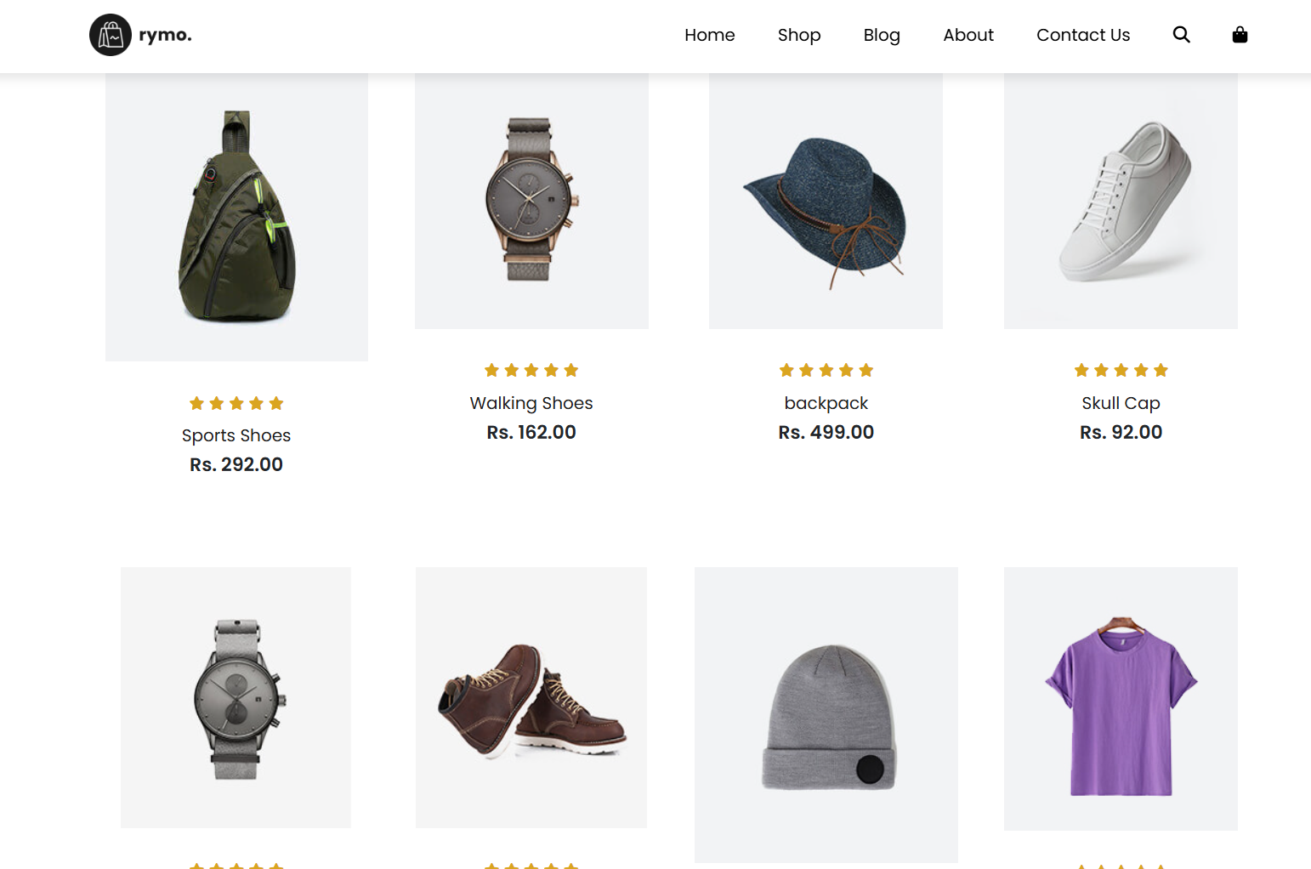

Now we got different products listings. But there is a difference in the size of the images used. To correct that we need to use styling. Instead of using in style sheet. We can use internal styling within the shop.html file.

  <style>

    .product img {

        width: 100%;

        height: auto;

        box-sizing: border-box;

        object-fit: cover; // Image fills the box, but top/bottom (or sides) get cut off.

    }

  </style>

Now we have to add the pagination. To do that we have go to bootstrap and search for pagination. Under the last product div we need to paste the pagination code that we copied from the bootstrap

<nav aria-label="...">

  <ul class="pagination">

    <li class="page-item disabled">

      <a class="page-link">Previous</a>

    </li>

    <li class="page-item"><a class="page-link" href="#">1</a></li>

    <li class="page-item active">

      <a class="page-link" href="#" aria-current="page">2</a>

    </li>

    <li class="page-item"><a class="page-link" href="#">3</a></li>

    <li class="page-item">

      <a class="page-link" href="#">Next</a>

    </li>

  </ul>

</nav>

Active page is moved to page to 2 to 1 by changing it in the class= “page-item active”

<li class="page-item active"><a class="page-link" href="#">1</a></li>

To style the pagination, go to inspect and copy the selector and paste it in the style section.

Change the background color to black.

#Featured > div.row.mx-auto.container > nav > ul > li.page-item.active > a {

        background-color: black;

    }

To create the hover effect and change the background color and text color to change, apply the below code

#Featured > div.row.mx-auto.container > nav > ul > li:nth-child(n):hover>a{

        background-color: coral;

        color: #fff;

    }

To make the entire pagination to change the color from blue to black.

.pagination a {

        color: #000;

    }

The heading featured is now in h2 tag instead of h3 and also used bootstrap **class font-weight-bold**

<h2 class="font-weight-bold">Our Featured</h2>

When we are in the shop page, the shop link should be active, for that we need to add “active” in the class nav-link

<li class="nav-item"><a class="nav-link active" href="#">Shop</a></li>

This active class will show the current page you are in.

<li class="nav-item"><a class="nav-link" href="index.html">Home</a></li>

          <li class="nav-item"><a class="nav-link active" href="shop.html">Shop</a></li>

Up to this Shop page is completed.

Now this is a **Single Product Page**

As usual need to create a new file in the same folder like before. Name and save the file as **singleProduct.html**.

Copy the first part from the shop.html page which includes **bootstrap**, **font awesome** and **style sheet**.

<!DOCTYPE html>

<html lang="en">

<head>

  <meta charset="UTF-8">

  <meta name="viewport" content="width=device-width, initial-scale=1.0">

  <title>Rymo.com Shop Page</title>

  <!-- Bootstrap 4 CSS -->

  <link rel="stylesheet" href="https://cdn.jsdelivr.net/npm/bootstrap@4.1.3/dist/css/bootstrap.min.css" crossorigin="anonymous">

  <!-- Font Awesome -->

  <link rel="stylesheet" href="https://cdnjs.cloudflare.com/ajax/libs/font-awesome/6.5.2/css/all.min.css" crossorigin="anonymous" referrerpolicy="no-referrer" />

  <link rel="stylesheet" href="style.css">

</head>

<body>

Copy and paste the JS

  <!-- Bootstrap 4 JS + Popper -->

  <script src="https://code.jquery.com/jquery-3.3.1.slim.min.js" crossorigin="anonymous"></script>

  <script src="https://cdn.jsdelivr.net/npm/popper.js@1.14.3/dist/umd/popper.min.js" crossorigin="anonymous"></script>

  <script src="https://cdn.jsdelivr.net/npm/bootstrap@4.1.3/dist/js/bootstrap.min.js" crossorigin="anonymous"></script>

</body>

</html>

Also copy and paste the nav bar and footer section

<!--Navigation-->

  <nav class="navbar navbar-expand-lg navbar-light bg-white py-3 fixed-top">

    <div class="container">

      <img src="img/logo1.png" alt="nav logo1" style="height:40px;">

      <button class="navbar-toggler" type="button" data-toggle="collapse" data-target="#navbarSupportedContent"

              aria-controls="navbarSupportedContent" aria-expanded="false" aria-label="Toggle navigation">

        <span id="bar"><i class="fa-solid fa-bars"></i></span>

      </button>

      <div class="collapse navbar-collapse" id="navbarSupportedContent">

        <ul class="navbar-nav ml-auto">

          <li class="nav-item"><a class="nav-link" href="index.html">Home</a></li>

          <li class="nav-item"><a class="nav-link active" href="shop.html">Shop</a></li>

          <li class="nav-item"><a class="nav-link" href="#">Blog</a></li>

          <li class="nav-item"><a class="nav-link" href="#">About</a></li>

          <li class="nav-item"><a class="nav-link" href="#">Contact Us</a></li>

          <li class="nav-item d-flex align-items-center">

            <a class="nav-link" href="#"><i class="fa-solid fa-magnifying-glass"></i></a>

            <a class="nav-link" href="#"><i class="fa-solid fa-shopping-bag"></i></a>

          </li>

        </ul>

      </div>

    </div>

  </nav>

<!--Footer Section-->

  <footer class="mt-5 py-5">

    <div class="row container mx-auto pt-5">

      <div class="footer-one col-lg-3 col-md-6 col-12">

        <img src="/img/logo2.png" alt="">

        <p class="pt-3">Rymo offers stylish, affordable fashion with quality and comfort,

           blending youthful energy and trendy designs in clothing, footwear, and accessories.</p>

      </div>

      <div class="footer-one col-lg-3 col-md-6 col-12 mb-3">

        <h5 class="pb-2">Featured</h5>

        <ul class="text-uppercase list-unstyled">

          <li><a href="#">Men</a></li>

          <li><a href="#">Women</a></li>

          <li><a href="#">New Arrivals</a></li>

          <li><a href="#">Shoes</a></li>

          <li><a href="#">Clothes</a></li>

        </ul>

      </div>

      <div class="footer-one col-lg-3 col-md-6 col-12 mb-3">

        <h5 class="pb-2">Contact Us</h5>

          <div>

            <h6 class="text-uppercase">Address</h6>

            <p>R.S.Puram,CBE,India</p>

          </div>

          <div>

            <h6 class="text-uppercase">Phone</h6>

            <p>0422 2348956</p>

          </div>

          <div>

            <h6 class="text-uppercase">Email</h6>

            <p>reach_us@rymo.com</p>

          </div>

      </div>

      <div class="footer-one col-lg-3 col-md-6 col-12">

        <h5 class="pb-2">Instagram</h5>

          <div class="row">

            <img class="img-fluid w-25 h-100 m-2" src="/img/insta/1.jpg" alt="">

            <img class="img-fluid w-25 h-100 m-2" src="/img/insta/2.jpg" alt="">

            <img class="img-fluid w-25 h-100 m-2" src="/img/insta/3.jpg" alt="">

            <img class="img-fluid w-25 h-100 m-2" src="/img/insta/4.jpg" alt="">

            <img class="img-fluid w-25 h-100 m-2" src="/img/insta/5.jpg" alt="">

          </div>

      </div>

    </div>

    <div class="copyright mt-5">

      <div class="row container mx-auto">

        <div class="col-lg-3 col-md-6 col-12 mb-4">

          <img src="img/payment.png" alt="">

        </div>

        <div class="col-lg-4 col-md-6 col-12 text-nowrap mb-2">

          <p>rymo eCommerce © 2025. All rights reserved</p>

        </div>

        <div class="col-lg-4 col-md-6 col-12">

          <a href="#"><i class="fa-brands fa-facebook-f"></i></a>

          <a href="#"><i class="fa-brands fa-twitter"></i></a>

          <a href="#"><i class="fa-brands fa-linkedin"></i></a>

        </div>

      </div>

    </div>

  </footer>

Now we need to add product details, create a section under the navigation section.

<!--Product Details-->

  <section class="sproduct">

    <div class="row">

        <div></div>

        <div></div>

    </div>

  </section>

We use class “**sproduct**”. Inside that we create a div tag for adding the product details.

In single row we have two columns one for image and one for details, so inside this div we create two div elements again. We use **bootstrap class= “row”** for the main div.

<div class="col-lg-5 col-md-12 col-12">

            <img src="/img/shop/1.jpg" alt="">

        </div>

First column we add **bootstrap class = “col-lg-5 col-md-12 col-12”** for responsive design and add image source.

<section class="sproduct my-5 pt-5">

    <div class="row mt-5">

Need to add margin and padding for the section margin top and bottom -5 and padding top -5. Likewise div class margin top -5.

To remove the slider in the bottom we need to add another bootstrap class = “container”

<section class="container sproduct my-5 pt-5">

<img class="img-fluid w-100" src="/img/shop/1.jpg" alt="">

We need to add **img bootstrap class = “img-fluid and width 100**”.

<div class="small-img-group">

Create a new div with class = “small-img-group” where we four images will be placed in the column wise.

                <div class="small-img-col">

                    <img src="img/shop/1.jpg" width="100%" class="small-img" alt="">

                </div>

                <div class="small-img-col">

                    <img src="img/shop/24.jpg" width="100%" class="small-img" alt="">

                </div>

                <div class="small-img-col">

                    <img src="img/shop/25.jpg" width="100%" class="small-img" alt="">

                </div>

                <div class="small-img-col">

                    <img src="img/shop/26.jpg" width="100%" class="small-img" alt="">

                </div>

Now to make the 4 images in single row, we need to style them using the bootstrap class using internal styling method.

.small-img-group {

        display: flex;

        justify-content: space-between;

    }

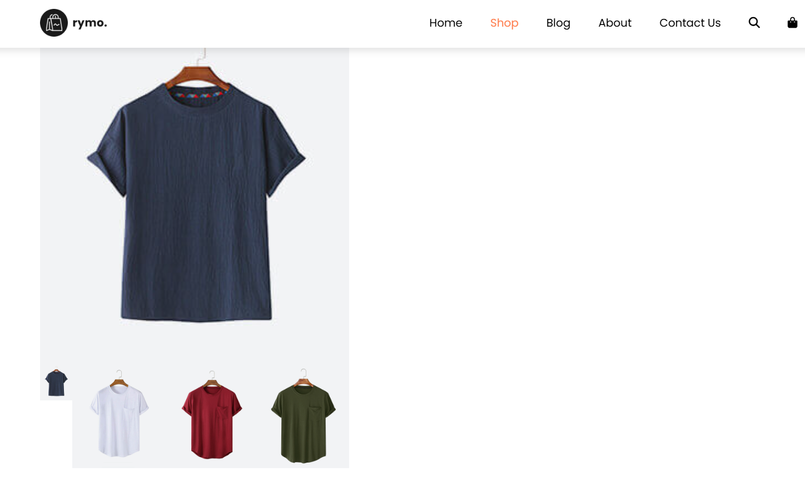

Now if we see all four images are in one row but the need some more tweaking.

.small-img-col {

        flex-basis: 24%;

        cursor: pointer;

    }

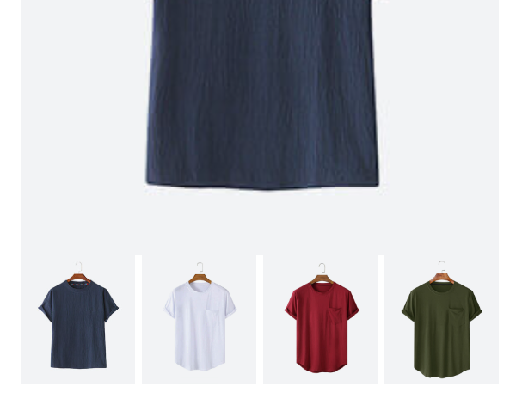

Now all four images are properly aligned. We have to add some spacing from the top image to the images below. For that we need to add padding bottom-1 to the top image class

<img class="img-fluid w-100 pb-1" src="/img/shop/1.jpg" alt="">

For the right section, we need to add details in the div section

<div class="col-lg-6 col-md-12 col-12">

          <h6>Home / Tees</h6>

          <h3 class="py-2.5">Mens Fashion Tees </h3>

          <h2>Rs. 299.00</h2>

          <select class="my-3">

            <option>Select Size</option>

            <option>XL</option>

            <option>XXL</option>

            <option>Small</option>

            <option>Medium</option>

            <option>Large</option>

          </select>

          <input type="number" value="1">

          <button class="buy-btn">Add To Cart</button>

          <h4 class="mt-3 mb-3">Product Details</h4>

          <span>Men’s tees crafted from premium, breathable fabric for lasting comfort and durability.

            Soft, lightweight, and stylish – perfect for casual wear or layering. Designed for all-day ease with a modern fit.</span>

        </div>

In here we used h6, h4, h3, h2, select tag, input tag, and button. Styling for all these mentioned tags are given below.

.sproduct select {

      display: block;

      padding: 5px 10px;

    }

    .sproduct input {

      width: 50px;

      height: 40px;

      padding-left: 10px;

      font-size: 16px;

      margin-right: 10px;

    }

    .sproduct input:focus {

      outline: none;

    }

    .buy-btn {

      background-color: coral;

      opacity: 1;

      transition: 0.3s all;

    }

To add the featured section below, copy paste the featured section from index.html to singleProduct.html

<script>

    var MainImg=document.getElementById('MainImg');

    var smallImg=document.getElementsByClassName('small-img');

    smallImg[0].onclick=function() {

        MainImg.src=smallImg[0].src;

    }

    smallImg[1].onclick=function() {

        MainImg.src=smallImg[1].src;

    }

    smallImg[2].onclick=function() {

        MainImg.src=smallImg[2].src;

    }

    smallImg[3].onclick=function() {

        MainImg.src=smallImg[3].src;

    }

  </script>

A simple JavaScript slider for choosing different colors of the tees.

<div onclick="window.location.href='singleProduct.html';"

When clicked on to the product in the shop page it will get into the product details page showing different colors available, size and add to cart.

Up to this SingleProduct section is completed.

Next section is Blog Page

Create a new file blog.html and save it. Now go to the index.html file and copy paste the code in blog.html file.

<!DOCTYPE html>

<html lang="en">

<head>

  <meta charset="UTF-8">

  <meta name="viewport" content="width=device-width, initial-scale=1.0">

  <title>Rymo.com Home Page</title>

  <!-- Bootstrap 4 CSS -->

  <link rel="stylesheet" href="https://cdn.jsdelivr.net/npm/bootstrap@4.1.3/dist/css/bootstrap.min.css" crossorigin="anonymous">

  <!-- Font Awesome -->

  <link rel="stylesheet" href="https://cdnjs.cloudflare.com/ajax/libs/font-awesome/6.5.2/css/all.min.css" crossorigin="anonymous" referrerpolicy="no-referrer" />

  <link rel="stylesheet" href="style.css">

</head>

<body>

  <!--Navigation-->

  <nav class="navbar navbar-expand-lg navbar-light bg-white py-3 fixed-top">

    <div class="container">

      <img src="img/logo1.png" alt="nav logo1" style="height:40px;">

      <button class="navbar-toggler" type="button" data-toggle="collapse" data-target="#navbarSupportedContent"

              aria-controls="navbarSupportedContent" aria-expanded="false" aria-label="Toggle navigation">

        <span id="bar"><i class="fa-solid fa-bars"></i></span>

      </button>

      <div class="collapse navbar-collapse" id="navbarSupportedContent">

        <ul class="navbar-nav ml-auto">

          <li class="nav-item"><a class="nav-link active" href="index.html">Home</a></li>

          <li class="nav-item"><a class="nav-link" href="shop.html">Shop</a></li>

          <li class="nav-item"><a class="nav-link" href="#">Blog</a></li>

          <li class="nav-item"><a class="nav-link" href="#">About</a></li>

          <li class="nav-item"><a class="nav-link" href="#">Contact Us</a></li>

          <li class="nav-item d-flex align-items-center">

            <a class="nav-link" href="#"><i class="fa-solid fa-magnifying-glass"></i></a>

            <a class="nav-link" href="#"><i class="fa-solid fa-shopping-bag"></i></a>

          </li>

        </ul>

      </div>

    </div>

  </nav>

Now we add footer section

  <!--Footer Section-->

  <footer class="mt-5 py-5">

    <div class="row container mx-auto pt-5">

      <div class="footer-one col-lg-3 col-md-6 col-12">

        <img src="/img/logo2.png" alt="">

        <p class="pt-3">Rymo offers stylish, affordable fashion with quality and comfort,

           blending youthful energy and trendy designs in clothing, footwear, and accessories.</p>

      </div>

      <div class="footer-one col-lg-3 col-md-6 col-12 mb-3">

        <h5 class="pb-2">Featured</h5>

        <ul class="text-uppercase list-unstyled">

          <li><a href="#">Men</a></li>

          <li><a href="#">Women</a></li>

          <li><a href="#">New Arrivals</a></li>

          <li><a href="#">Shoes</a></li>

          <li><a href="#">Clothes</a></li>

        </ul>

      </div>

      <div class="footer-one col-lg-3 col-md-6 col-12 mb-3">

        <h5 class="pb-2">Contact Us</h5>

          <div>

            <h6 class="text-uppercase">Address</h6>

            <p>R.S.Puram,CBE,India</p>

          </div>

          <div>

            <h6 class="text-uppercase">Phone</h6>

            <p>0422 2348956</p>

          </div>

          <div>

            <h6 class="text-uppercase">Email</h6>

            <p>reach_us@rymo.com</p>

          </div>

      </div>

      <div class="footer-one col-lg-3 col-md-6 col-12">

        <h5 class="pb-2">Instagram</h5>

          <div class="row">

            <img class="img-fluid w-25 h-100 m-2" src="/img/insta/1.jpg" alt="">

            <img class="img-fluid w-25 h-100 m-2" src="/img/insta/2.jpg" alt="">

            <img class="img-fluid w-25 h-100 m-2" src="/img/insta/3.jpg" alt="">

            <img class="img-fluid w-25 h-100 m-2" src="/img/insta/4.jpg" alt="">

            <img class="img-fluid w-25 h-100 m-2" src="/img/insta/5.jpg" alt="">

          </div>

      </div>

    </div>

    <div class="copyright mt-5">

      <div class="row container mx-auto">

        <div class="col-lg-3 col-md-6 col-12 mb-4">

          <img src="img/payment.png" alt="">

        </div>

        <div class="col-lg-4 col-md-6 col-12 text-nowrap mb-2">

          <p>rymo eCommerce © 2025. All rights reserved</p>

        </div>

        <div class="col-lg-4 col-md-6 col-12">

          <a href="#"><i class="fa-brands fa-facebook-f"></i></a>

          <a href="#"><i class="fa-brands fa-twitter"></i></a>

          <a href="#"><i class="fa-brands fa-linkedin"></i></a>

        </div>

      </div>

    </div>

  </footer>

  <!-- Bootstrap 4 JS + Popper -->

  <script src="https://code.jquery.com/jquery-3.3.1.slim.min.js" crossorigin="anonymous"></script>

  <script src="https://cdn.jsdelivr.net/npm/popper.js@1.14.3/dist/umd/popper.min.js" crossorigin="anonymous"></script>

  <script src="https://cdn.jsdelivr.net/npm/bootstrap@4.1.3/dist/js/bootstrap.min.js" crossorigin="anonymous"></script>

</body>

</html>

Now we work on the blog section

  <!--Blog Section-->

  <section id="blog-home" class="pt-5 mt-5 container">

        <h2 class="font-weight-bold pt-5" >Blogs</h2>

        <hr>

  </section>

Now we add one more section

<section id="blog-container" class="container pt-5">

This will create a container for all our blog posts. By adding class- container we add padding from left and for top we add padding top -5

We need all the blog posts in one row

<div class="row">

This is the div created for individual blog post

<div class="post col-lg-6 col-md-6 col-12 pb-5">

            <div class="post-img">

                <img class="img-fluid w-100" src="img/blog/1.jpg" alt="">

            </div>

            <h3 class="text-center font-weight-normal pt-3">The best ways to change your summer wardrobe into autumn wardrobe.</h3>

            <p class="text-center">Jan 11, 2025</p>

        </div>

In that class for large screen we have 6 column and medium screen 6 and small screen 12 column with padding bottom 5.

We add bootstrap class “img-fluid” and width -100% for images.

For the heading of the blog post we use h3 tag. In that h3 tag we add bootstrap class “text-center font-weight normal and padding top -3” & for the date we use p tag with bootstrap class “text-center”.

To make the image hover effect, we need to go to style sheet. Copy the section id=blog-container and go to the style sheet.

#blog-container .post:hover img {

    transform: scale(1.3) rotate(-10deg);

    opacity: 0.8;

}

Using transform property you can scale the image to 1.3 and rotate it -10deg also set opacity to 0.8.

When you check the image while hovering it goes out of the screen. To fix that we need to do the following

#blog-container .post .post-img {

    overflow: hidden;

    cursor: pointer;

}

Overflow property hides the image within the screen and doesn’t allow to go outside it.

Now we need to add smooth transition to the image, by adding 0.3sec ease.

#blog-container .post-img {

    transition: 0.3s ease;

}

To add some transition to our heading

#blog-container .post:hover h3 {

    color: #fd8c66;

}

#blog-container .post:hover h3 {

    transition: 0.3s ease;

    cursor: pointer;

}

To make it smoother we add transition of 0.3 sec ease.

Now we are done with one blog post, we need to add multiple blog posts. Copy this and paste it below 3 times.

<div class="post col-lg-6 col-md-6 col-12 pb-5">

            <div class="post-img">

                <img class="img-fluid w-100" src="img/blog/1.jpg" alt="">

            </div>

            <h3 class="text-center font-weight-normal pt-3">The best ways to change your summer wardrobe into autumn wardrobe.</h3>

            <p class="text-center">Jan 11, 2025</p>

        </div>

Change the images and title of the blogs.

After the blog section we need to add banner below the blog posts.

<div class="col-lg-6 col-md-6 col-12 pb-5">

            <div class="post-img">

                <img class="img-fluid w-100" src="img/blog/banner.webp" alt="">

            </div>

        </div>

This banner is taking only 6 column setting, we need change it now. We change it from 6 to 12 col in all three screens.

<div class="col-lg-12 col-md-12 col-12 pb-5">

            <div class="post-img">

                <img class="img-fluid w-100" src="img/blog/banner.webp" alt="">

            </div>

        </div>

Now we need to create 3 small blog posts. For that again copy the div tag and change the col 4 in large screen and 6 in medium and 12 in small.

<div class="post col-lg-4 col-md-6 col-12 pb-5">

            <div class="post-img">

                <img class="img-fluid w-100" src="img/blog/4.jpg" alt="">

            </div>

            <h3 class="text-center font-weight-normal pt-3">Creative ways to mix summer staples with autumn colors.</h3>

            <p class="text-center">Apr 15, 2025</p>

        </div>

Now we need the heading to be in small size, we choose h4 instead of h3 and remove the text-center. Also remove the p tag which contains the date.

<div class="post col-lg-4 col-md-6 col-12 pb-5">

            <div class="post-img">

                <img class="img-fluid w-100" src="img/blog/4.jpg" alt="">

            </div>

            <h4 class="font-weight-normal pt-3">Creative ways to mix summer staples with autumn colors.</h4>

        </div>

Change the images and title of the blog posts.

<div class="post col-lg-4 col-md-6 col-12 pb-5">

            <div class="post-img">

                <img class="img-fluid w-100" src="img/blog/1.webp" alt="">

            </div>

            <h4 class="font-weight-normal pt-3">The Ultimate Summer Collection Guide: Trends That Redefine Fashion.</h4>

        </div>

Now we need to link the blog section. In index.html

<li class="nav-item"><a class="nav-link" href="blog.html">Blog</a></li>

In shop.html

<li class="nav-item"><a class="nav-link" href="blog.html">Blog</a></li>

In blog.html

<li class="nav-item"><a class="nav-link active" href="blog.html">Blog</a></li>

We need to mention active in class so that whenever we are in blog page it highlights the blog in different color.

This is end of Blog page.

Next section is cart page. Create a cart.html file

Copy the blog.html file and paste it in the cart.html file. Delete the blog section from the file. Change the name of the page to Shopping cart.

Below the section we need to create a new section for the table.

<section id="cart-container">

And within the section need to create a table

<table width="100%">

    </table>

Next we create a table header

<thead></thead>

Within that we need to create table row

<tr></tr>

Within that we need to create table data

<td>Remove</td>

                <td>Image</td>

                <td>Product</td>

                <td>Price</td>

                <td>Quantity</td>

                <td>Total</td>

To add padding to the table data, we need to add bootstrap class called container.

<section id="cart-container" class="container">

Need to add some margin from top and bottom. Another class my-5 which means margin top and bottom is 5.

<section id="cart-container" class="container my-5">

Now we need to add styles to the header, for that go to style sheet.

#cart-container table {

    border-collapse: collapse;

    width: 100%;

    table-layout: fixed;

}

We need to add font-weight to the table header

#cart-container table thead {

    font-weight: 700;

}

To add color, bg, border and padding to the table header

#cart-container table thead td {

    background-color: #fd8c66;

    color: #fff;

    border: none;

    padding: 6px 0;

}

Now we will the table body with table data (1st row)

<tbody>

          <tr>

            <td><a href="#"><i class="fas fa-trash-alt"></i></a></td>

            <td><img src="img/shoes/1.jpg" alt=""></td>

            <td><h5>Nike Sport Shoes</h5></td>

            <td><h5>Rs. 350</h5></td>

            <td><input type="number"></td>

            <td><h5>Rs. 350</h5></td>

          </tr>

        </tbody>

Quantity box size reduced by adding width and padding. The default value for the quantity will be 1.

<td><input class="w-25 pl-1" value="1" type="number"></td>

Now we need to style the first row

#cart-container table td {

    border: 1px solid #b6b3b3;

    text-align: center;

}

#cart-container table td:nth-child(1) {

    width: 100px;

}

#cart-container table td:nth-child(2)

#cart-container table td:nth-child(3) {

    width: 200px;

}

#cart-container table td:nth-child(4)

#cart-container table td:nth-child(5)

#cart-container table td:nth-child(6) {

    width: 170px;

}

#cart-container table tbody img {

    width: 100px;

    height: 80px;

    object-fit:cover;

}

Now we need to do second and third row. For that copy the table row and paste it two more times. Change the images and names for the other two rows.

<tr>

            <td><a href="#"><i class="fas fa-trash-alt"></i></a></td>

            <td><img src="img/shoes/1.jpg" alt=""></td>

            <td><h5>Nike Sport Shoes</h5></td>

            <td><h5>Rs. 350</h5></td>

            <td><input class="w-25 pl-1" value="1" type="number"></td>

            <td><h5>Rs. 350</h5></td>

          </tr>

To change the color of the delete icon

#cart-container table tbody i {

    color: #8d8c89;

}

Cart bottom section code

<section id="cart-bottom" class="container">

    <div class="row">

      <div class="coupon col-lg-6 col-md-6 col-12 mb-4">

        <div>

          <h5>COUPON</h5>

          <p>Enter your Coupon code if you have one.</p>

          <input type="text" placeholder="Coupon Code">

          <button>APPLY COUPON</button>

        </div>

      </div>

      <div class="Total col-lg-6 col-md-6 col-12">

        <div>

          <h5>Cart Total</h5>

          <div class="d-flex justify-content-between">

            <h6>Sub Total</h6>

            <p>Rs.500</p>

          </div>

          <div class="d-flex justify-content-between">

            <h6>Shipping</h6>

            <p>Rs.150</p>

          </div>

          <hr class="second-hr">

          <div class="d-flex justify-content-between">

            <h6>Total</h6>

            <p>Rs.150</p>

          </div>

          <button>PROCEED TO CHECKOUT</button>

        </div>

      </div>

    </div>

  </section>

To style the cart bottom section, copy the id and go to the style sheet

#cart-bottom .coupon>div,

#cart-bottom .Total>div {

    border: 1px solid #b6b3b3;

}

#cart-bottom .coupon h5,

#cart-bottom .Total h5 {

    background-color: #fd8c66;

    color: #fff;

    border: none;

    padding: 6px 12px;

    font-weight: 700;

}

#cart-bottom .coupon p,

#cart-bottom .coupon input {

    padding: 0 12px;

}

#cart-bottom .coupon input {

    height: 44px;

}

#cart-bottom .coupon input {

    margin: 0 0 20px 12px;

}

#cart-bottom .Total div>div {

    padding: 0 12px;

}

#cart-bottom .Total h6 {

    color: #2a2a2a;

}

.second-hr {

    background: #b8b7b3;

    width: 100%;

    height: 1px;

}

#cart-bottom .Total div>button {

    margin: 0 12px 20px 0;

    display: flex;

    justify-content: flex-end;

}

In html code

<button class="ml-auto">PROCEED TO CHECKOUT</button>

To make the website responsive to tablet and mobile phones

#cart-container {

    overflow-x: auto;

}

#cart-container table {

    border-collapse: collapse;

    width: 100%;

    table-layout: fixed;

    white-space: nowrap;

}